- The Bank of England's Financial Stability Report echoed our warnings that the impact of tighter monetary policy is still to fully pass through to households. The increase in debt servicing costs should be manageable for most, but there's a long tail of homeowners who face a large increase in mortgage payments over the next two years, once their current fixed rate deal expires.
- As we enter the final week of the general election campaign, all opinion polls and election models point to a large Labour majority. While we think a large majority would embolden a Labour government to pursue looser fiscal policy than its manifesto implies, we fear the new government will stop short of the comprehensive overhaul of fiscal policy that's so badly needed.
It's been a week very light on economic data. The sole Office for National Statistics release was the Quarterly National Accounts for Q1. This revised up q/q GDP growth in Q1 to 0.7% from 0.6%, on the back of a stronger pickup in consumer spending. Nevertheless, the increase in real household disposable income was greater still, meaning the savings ratio increased from an already-high level.
The only other data releases of note were the CBI's manufacturing and retail surveys for June. The manufacturing results were mixed, with a marked improvement in order books compared with May but output growth softening. Retail sales dropped sharply, after a better May, with a further fall anticipated next month. But these surveys have a very patchy record as leading indicators of official output trends, and we still expect to see decent GDP growth in Q2, if not quite as strong as Q1.
Elsewhere, the Bank of England published its six-monthly Financial Stability Report. The key finding echoed an argument that we’ve been making for some time, namely that there's many homeowners who are still to refinance from cheap mortgage deals, often taken out before the pandemic, to higher rates. The BoE estimates that over 3mn, or 35%, of mortgage accounts are paying rates of less than 3%, and that the majority of those borrowers will have a fixed rate deal that expires before the end of 2026 (Chart 1).
Chart 1: The impact of past interest rate rises still has much further to run
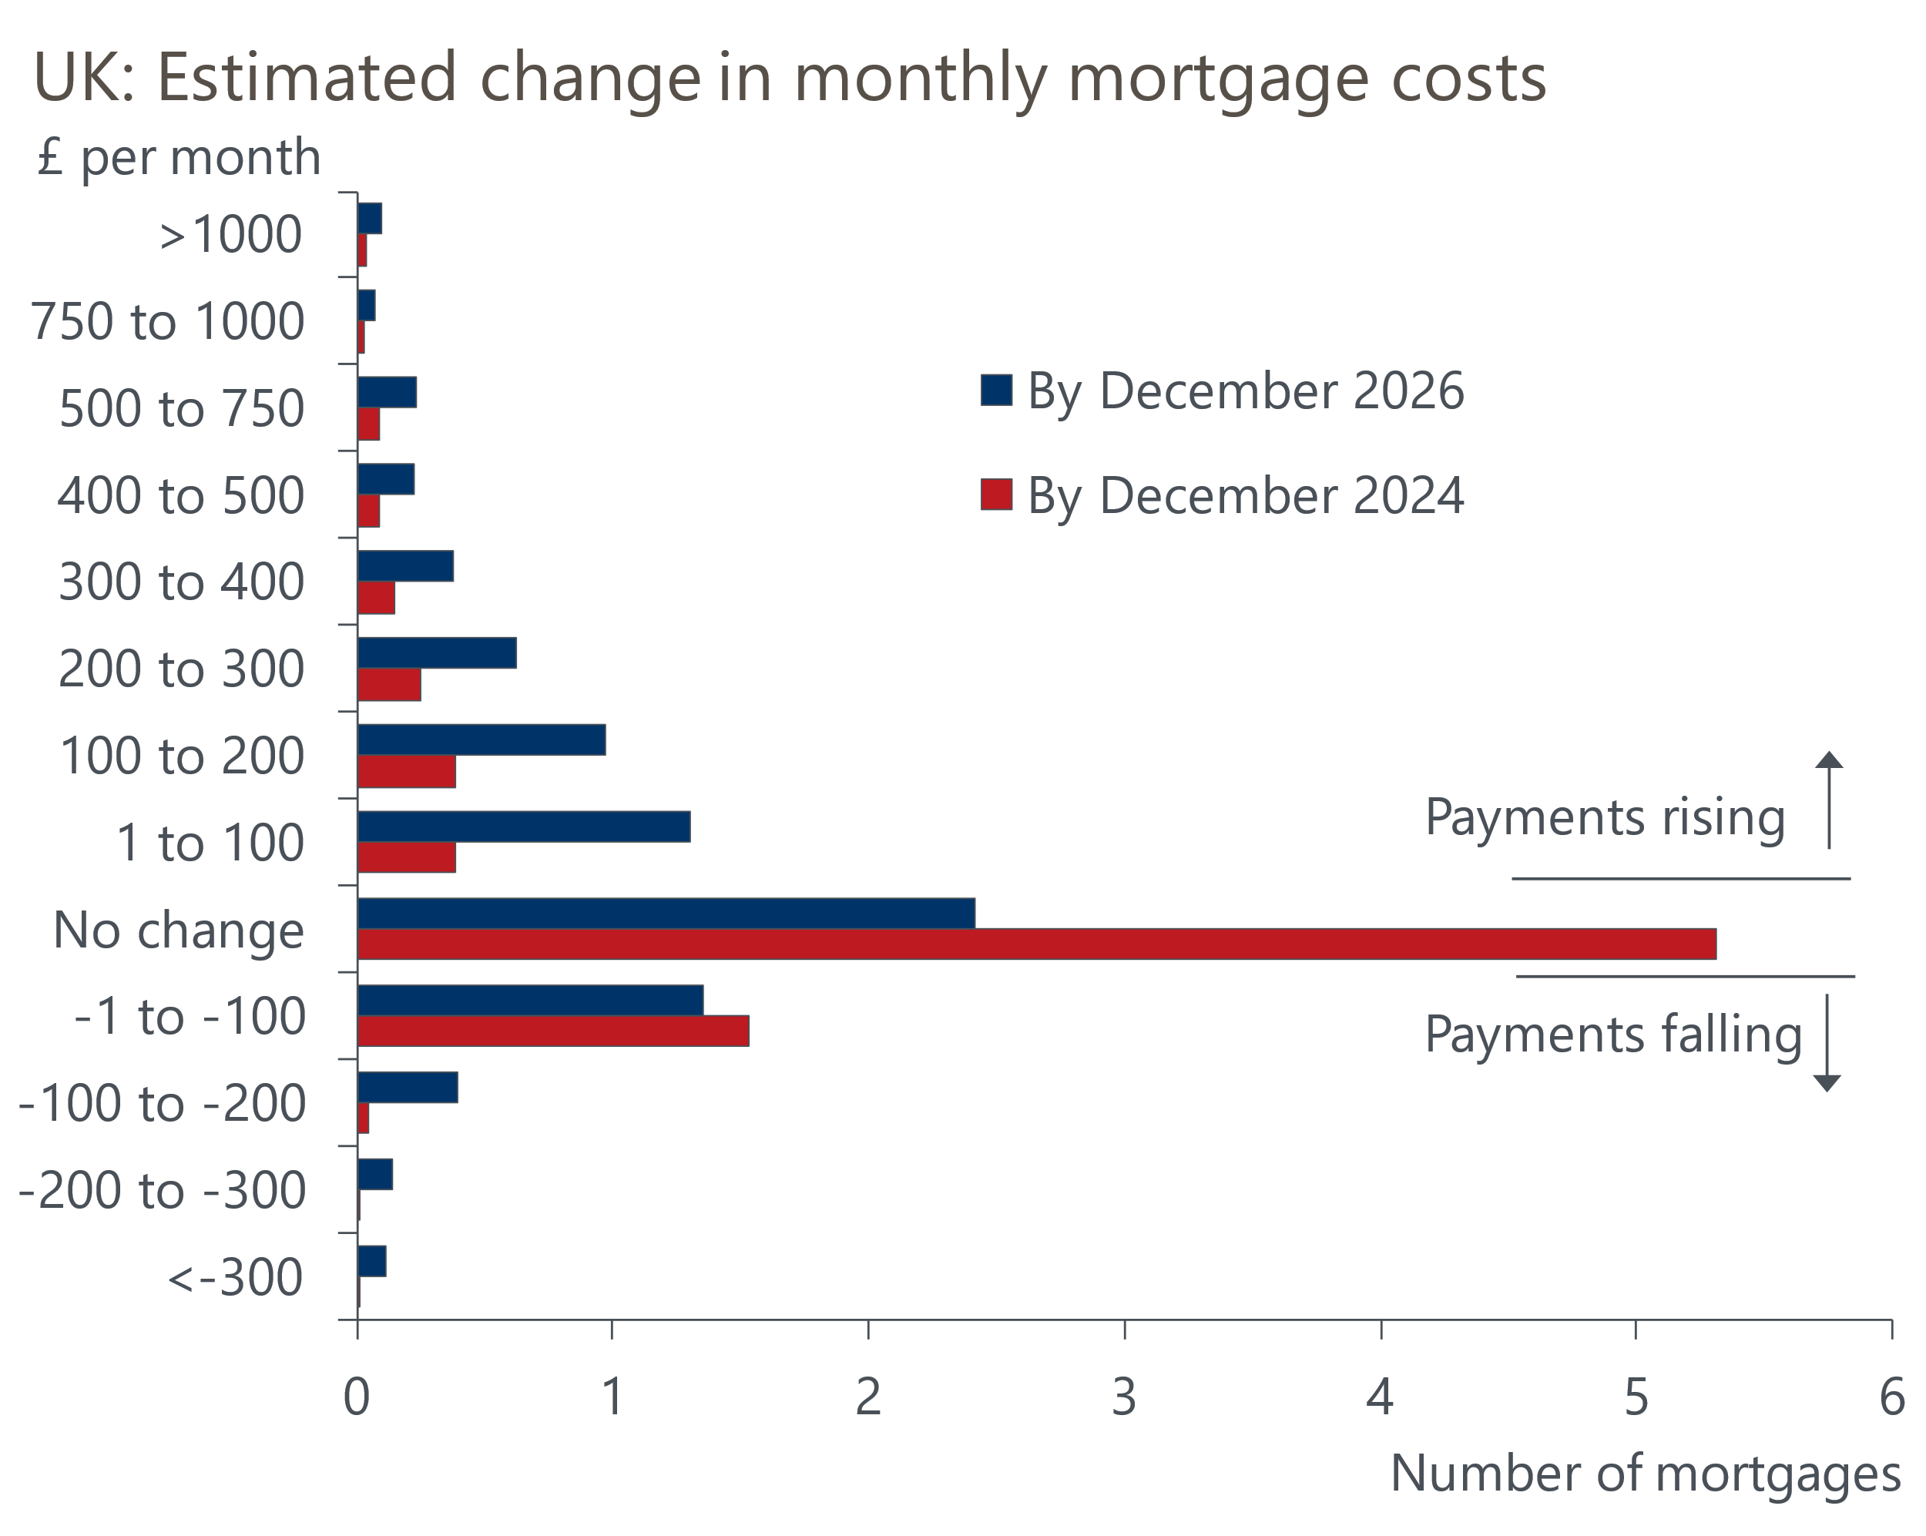
Source: Bank of England

The BoE forecast that this factor will more than offset the impact of falling variable rate mortgage costs, leading to a modest rise in the aggregate household debt-servicing ratio over the next couple of years. This is consistent with our own forecast, and we expect this factor to be a key constraint on the pace of GDP growth in 2024-2025. For most households these increases should be manageable, but with the BoE estimating that 400,000 households face an increase in their monthly mortgage payment of 50% or more, there's a long tail of households who look vulnerable. We plan to look in more detail at the outlook for mortgage arrears and repossessions in a forthcoming Research Briefing.
The general election campaign has entered its final week. There's been a vast number of opinion polls published over the course of the first five weeks of the campaign, but the movement has been small, and the common narrative is that the opposition Labour party is on course to achieve a comfortable victory.
On June 27, the Financial Times' poll tracker showed Labour on 41%, with the Conservatives a distant second on 20%. A further two parties – Reform UK (16%) and Liberal Democrats (12%) – are polling above 10%, so support is spread relatively widely. But that support tends not to be spread evenly across seats, and given the UK operates a 'first-past-the-post' system, the 'efficiency' with which votes are translated into parliamentary seats will vary significantly across parties. For example, the Liberal Democrats are likely to win far more seats than Reform UK, despite enjoying lower support at a national level.
The most effective method of trying to predict the election outcome tends to be the use of multilevel regression and post-stratification (MRP) models. These models combine opinion polls with demographic information to produce seat-by-seat forecasts. But the unusual pattern of support means that these models are coming up with a wider range of possible outcomes than in past elections.
Six MRPs have been published in the past two weeks, and on average they predict that Labour will win 453 of the 650 parliamentary seats, giving them a majority of 255 (Chart 2). But the estimates for Labour's seat tally range from 406-516, offering a range of possible majorities from 162 to 382. The very wide range is because many seats are likely to be close calls. In Ipsos's MRP, they identified 117 seats (18%) where the winning margin was less than 5%, which they deem to be 'too close to call'. Many experts also expect there will be more tactical voting than normal, with the MRPs allowing for this factor to varying degrees.
Chart 2: MRPs suggest Labour is on track to win a majority of more than 250 seats
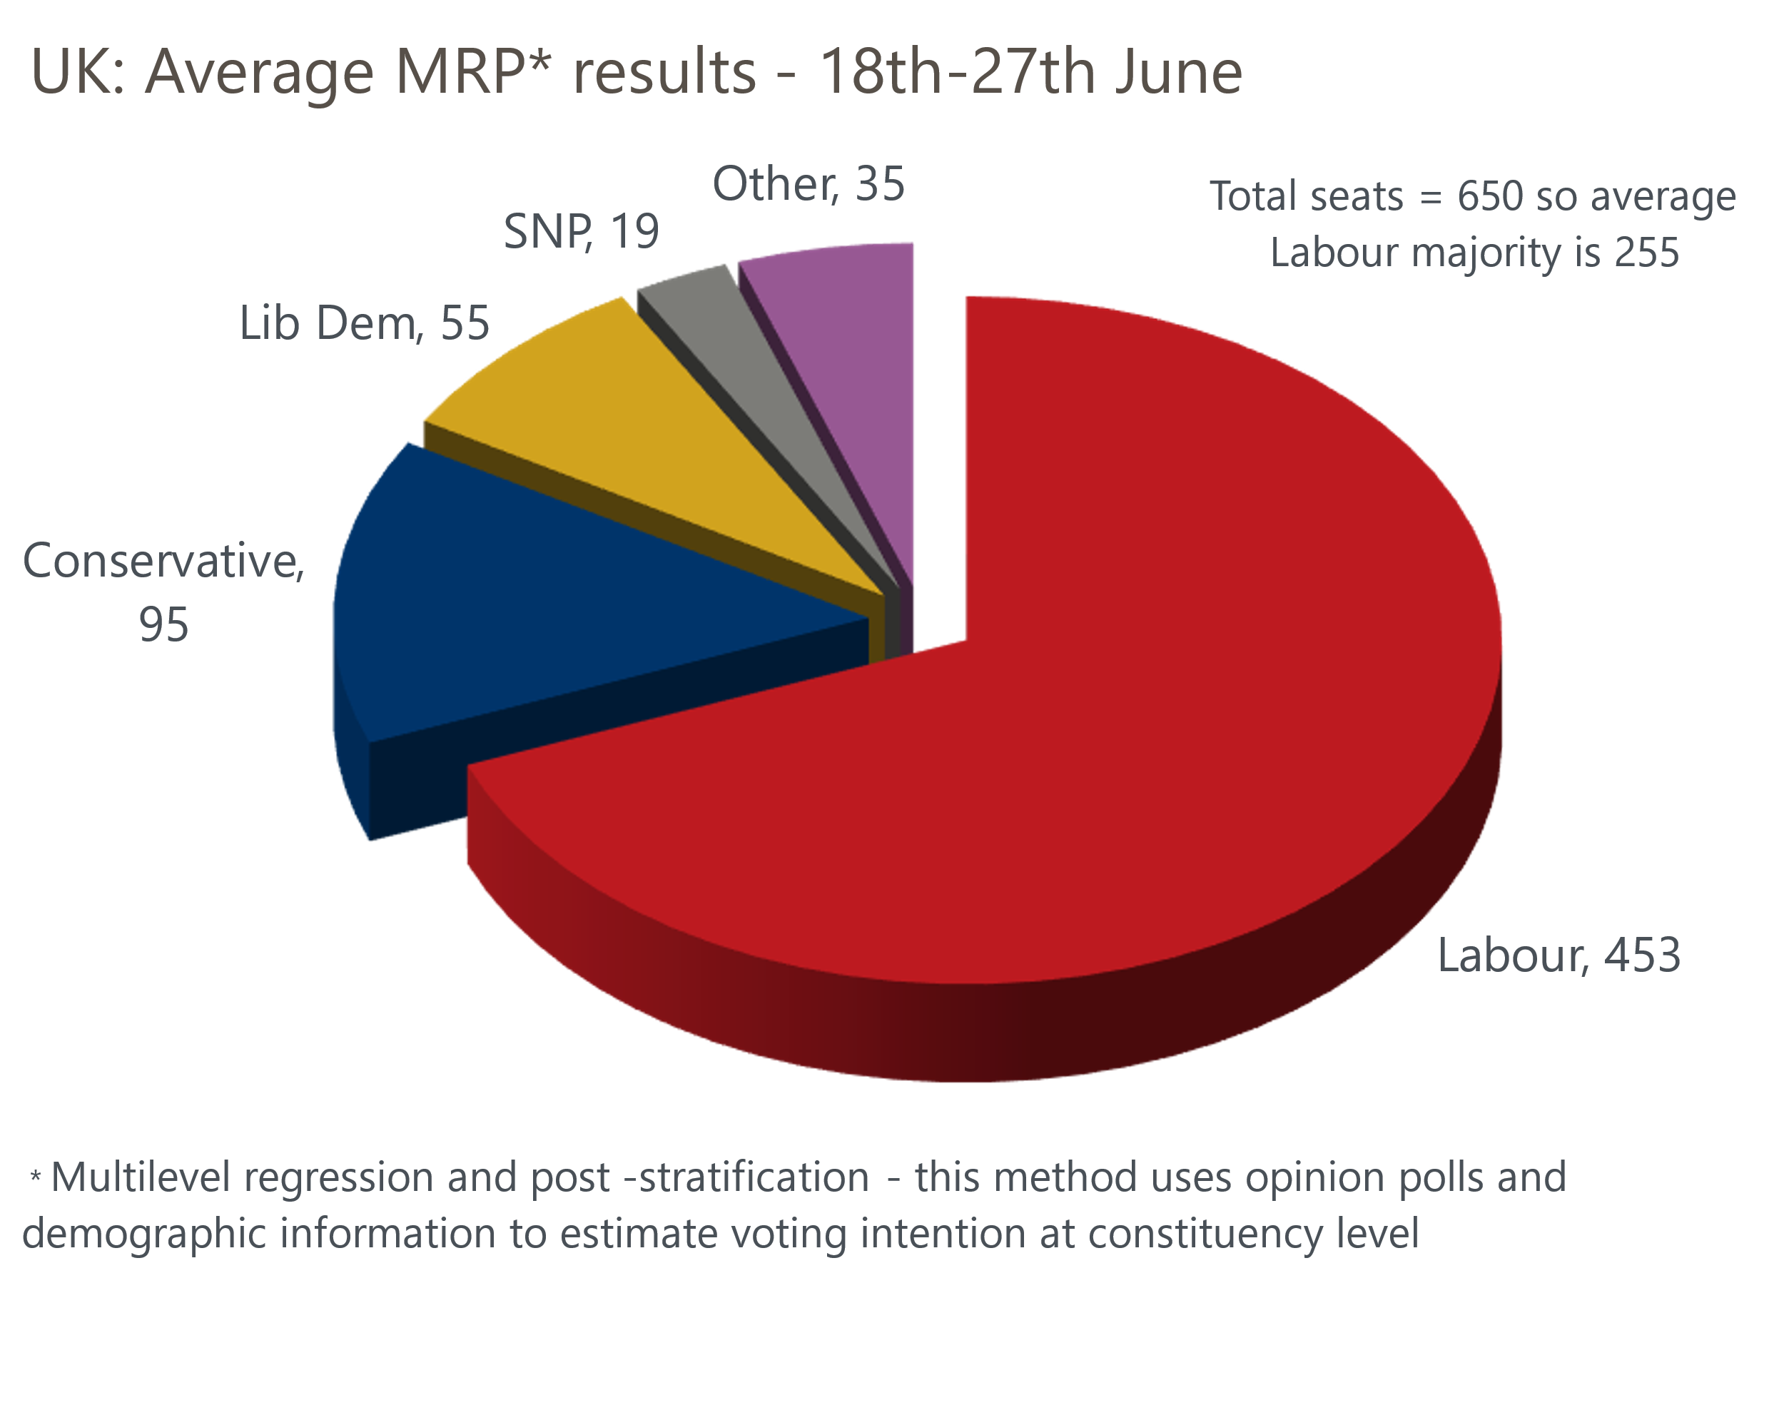
Source: Oxford Economics calculations using data from Electoral Calculus, We Think, YouGov, More In Common, Savanta, and Ipsos
Even if Labour's majority was 162, the bottom of the range of MRPs, the new government would face few constraints on its policymaking. This would be double the size of the majority won by the Conservatives in 2019, and only just short of the 179 seat majority won by Labour under Tony Blair in 1997. As we argued in a recent note, we suspect that a majority of this size would embolden Labour to go beyond its manifesto pledges and implement slightly looser fiscal policy than the current plans, focused on higher government spending. But we fear they will stop short of the bigger overhaul of fiscal policy that's so badly needed.

The week ahead
Next week sees a clutch of lending and housing market data published, plus the final S&P Global surveys for June.
We expect Monday's Bank of England Money & Credit release will show only a small increase in mortgage approvals to 61,600 in May, from 61,140 in April, with the increase in quoted mortgage rates since the spring weighing on the recovery in demand. Higher mortgage rates are also likely to mean that the Nationwide and Halifax indices, due out next week, show that house prices were broadly flat in June.
But the data on lending flows should be firmer because of the lag between a mortgage being approved and the funds being dispensed. We forecast that net mortgage lending will rise to £3.1bn in May, from £2.4bn in April, because the pickup in approvals around the turn of the year should have translated into stronger gross lending flows in May.
On the unsecured side, April's outturn for net lending was dragged down by an unusually weak reading for gross lending. This chimed in with the slump in retail sales that month and could reflect the earlier-than-normal Easter. With retail sales having rebounded strongly in May, we expect a similar pickup in net unsecured lending to £1.5bn.
June's flash S&P Global survey reported a drop in the composite PMI due to softer services activity. But the survey results can be very volatile from month-to-month, so we won't be unduly concerned if the final results come in close to the flash readings.
Table 1: Week ahead calendar
Date | Events | Period | Measure | Unit | Previous | Forecast
Jul 1 | Nationwide house prices | Jun | m/m | % | 0.4 | 0.0
Jul 1 | Nationwide house prices | Jun | y/y | % | 1.3 | 1.2
Jul 1 | S&P Global/CIPS manufacturing | Jun | PMI | % bal | 51.4 | 51.4
Jul 1 | Mortgage approvals | May | Level | 000s | 61.1 | 61.6
Jul 1 | Mortgage lending | May | Net lending | £bn | 2.4 | 3.1
Jul 1 | Consumer credit | May | Net lending | £bn | 0.7 | 1.5
Jul 3 | S&P Global/CIPS services | Jun | PMI | % bal | 51.2 | 51.2
Jul 3 | S&P Global/CIPS composite | Jun | PMI | % bal | 51.7 | 51.7
Jul 4 | S&P Global/CIPS construction | Jun | PMI | % bal | 54.7 | 54.0
Jul 5 | Halifax house prices | Jun | m/m | % | -0.1 | -0.1
Jul 5 | Halifax house prices | Jun | y/y | % | 1.5 | 0.8
Source: Oxford Economics

Key forecasts
Table 2: UK forecast overview
(Annual percentage changes unless specified)
 | 2022 | 2023 | 2024 | 2025 | 2026 | 2027
GDP | 4.3 | 0.1 | 0.9 | 2.0 | 1.9 | 1.6
Private consumption | 4.8 | 0.2 | 0.7 | 2.6 | 2.2 | 1.6
Fixed investment | 8.0 | 2.2 | -0.5 | 0.8 | 2.7 | 2.1
Government consumption | 2.3 | 0.5 | 3.4 | 2.8 | 1.6 | 1.5
Exports of goods and services | 9.0 | -0.5 | -0.9 | 2.7 | 2.3 | 1.7
Imports of goods and services | 14.6 | -1.5 | 0.2 | 4.7 | 2.9 | 1.9
Industrial Production | -3.5 | -0.4 | 0.3 | 0.9 | 1.5 | 1.1
Consumer prices | 9.1 | 7.3 | 2.5 | 2.5 | 2.3 | 2.2
Unemployment rate (%) | 3.9 | 4.0 | 4.3 | 4.0 | 3.8 | 3.8
Current a/c balance (% of GDP) | -3.1 | -3.3 | -2.7 | -3.2 | -3.2 | -3.1
Government balance (% of GDP) | 4.4 | 5.0 | 3.7 | 3.2 | 2.4 | 1.5
Cen. bank policy rate (%, EOP) | 3.50 | 5.25 | 4.75 | 3.75 | 2.75 | 2.00
10yr govt. bond yield (%, EOP) | 3.67 | 3.54 | 4.00 | 3.66 | 3.18 | 2.85
Exchange rate (US$ per £, EOP) | 1.20 | 1.27 | 1.26 | 1.27 | 1.30 | 1.32
Exchange rate (euro per £, EOP) | 1.13 | 1.15 | 1.17 | 1.17 | 1.17 | 1.16
Source: Oxford Economics
Table 3: Quarterly forecasts for the UK
 | 2024 |  |  |  | 2025
 | Q1 | Q2 | Q3 | Q4 | Q1 | Q2 | Q3 | Q4
GDP (% year) | 0.2 | 0.4 | 1.0 | 1.8 | 1.7 | 2.1 | 2.2 | 2.2
CPI inflation (% year) | 3.5 | 2.1 | 2.0 | 2.5 | 2.5 | 2.3 | 2.6 | 2.4
Bank Rate (%, EOP) | 5.25 | 5.25 | 5.00 | 4.75 | 4.50 | 4.25 | 4.00 | 3.75
10yr gilt yield (%, EOP) | 3.95 | 4.15 | 4.06 | 4.00 | 3.93 | 3.85 | 3.76 | 3.66
US$ per £ (EOP) | 1.26 | 1.26 | 1.26 | 1.26 | 1.26 | 1.26 | 1.27 | 1.27
Euro per £ (EOP) | 1.17 | 1.17 | 1.17 | 1.17 | 1.17 | 1.17 | 1.17 | 1.17
Source: Oxford Economics

Latest Country Economic Forecast:
June 18, 2024

Recent publications

Data Insights
National accounts point to a slightly stronger start to 2024
Flash PMIs suggest the economic recovery slowed in June
Retail sales bounced back in May
Government borrowing running slightly above expectations
CPI inflation returned to the BoE's 2% target in May

Research Briefings
MPC prepares the ground for an August rate cut
Why Labour and Tory manifestos are a missed opportunity
MPC preview – The clues will be in the language
Will the BoE slow QT?
Why the neutral interest rate will stay structurally low

Contacts

Oxford Economics' UK team
- Andrew Goodwin - Chief UK Economist - agoodwin@oxfordeconomics.com
- Edward Allenby - UK Economist - eallenby@oxfordeconomics.com

